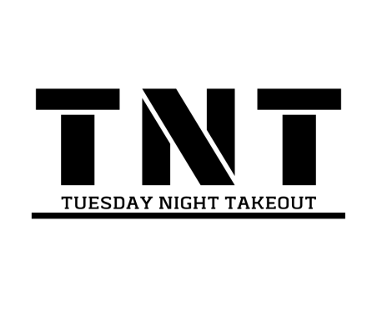
Hey Takeout!
Exciting times…You are all invited to the launch of the 'Graham Tour' in Liverpool! Most of you will know Sam Knott (leader on Youth Alpha last year) - he is part of the team who are bringing a huge stadium event to Liverpool next summer which will include bands, great speakers and most importantly the opportunity for people to hear and respond to the good news of Jesus.
It would be great to support him at the launch event for this which will involve worship, teaching and loads more information about the vision for the event in the summer. It is at Anfield Stadium in Liverpool, on Fri 25th October, 7pm*.
Ideally we'd like to get some of your parents on board as well and have a few cars going down. Please note that the adults in each car coming down would take full responsibility for those travelling with them during the event, though we will *meet outside at 6.15 and try and sit all together. Best of all, all of these events are completely free! If you would like to come please fill in the slip below and return it by Tues 22nd Oct to help with our planning.
See you there!
Rachel
……………………………………………………………………………………………………………
Yes I'd like to come to the Billy Graham Tour Launch Event on Fri 25th Oct 2019 at Anfield Stadium, Liverpool.

Name:
I will be getting a lift with ...............................
There are ........... remaining spaces in my car.
I don't have a lift please put me in contact with someone who has space.

I understand that the adults in each car coming down will take full responsibility for those travelling with them during the event.
Signed driver........................... Name…………..……….. Date..............
Signed parent (if different) ......................... Name……………..… Date............

