100 fiction books all children should read before leaving primary school:
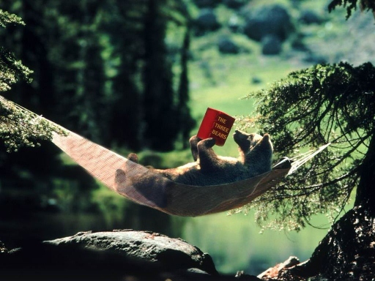

1 Charlie and the Chocolate Factory by Roald Dahl
2 Goodnight Mister Tom by Michelle Magorian
3 Alice in Wonderland by Lewis Carroll
4 Matilda by Roald Dahl
5 The Gruffalo by Julia Donaldson
6 The Chronicles of Narnia by C S Lewis
7 The Very Hungry Caterpillar by Eric Carle
8 We're Going on a Bear Hunt by Michael Rosen
9 Dogger by Shirley Hughes
10 Where the Wild Things Are by Maurice Sendak
11 Stig of the Dump by Clive King
12= Black Beauty by Anna Sewell
12= The Iron Man by Ted Hughes
14 Flat Stanley by Jeff Brown
15 Winnie the Pooh by A A Milne
16 Funnybones by Allan and Janet Ahlberg
17= Owl Babies by Martin Waddell and Patrick Benson
17= The Hobbit by J R R Tolkien
19 Green Eggs and Ham by Dr Seuss
20 War Horse by Michael Morpurgo
21= Grimm’s Fairy Tales by The Brothers Grimm
21= The Tiger Who Came to Tea by Judith Kerr
23 Peace at Last by Jill Murphy
24 Artemis Fowl series by Eoin Colfer
25 Hairy Maclary from Donaldson's Dairy by Lynley Dodd
26 Not Now Bernard by David Mckee
27 Diary of a Wimpy Kid by Jeff Kinney
28 The Twits by Roald Dahl
29 I am David by Anne Holm
30 The Highwayman by Alfred Noyes
31 The Paddington series by Michael Bond
32 Amazing Grace by Mary Hoffman and Caroline Binch
33 Esio Trot by Roald Dahl
34 Five Children and It by E Nesbit
35 Clockwork by Phillip Pullman
36 The Secret Garden by Frances Hodgson Burnett
37 The Magic Far Away Tree by Enid Blyton
38 Farmer Duck by Martin Waddell and Helen Oxenbury
39 Swallows and Amazons by Arthur Ransome
40 The Silver Sword by Ian Serraillier
41 The Worst Witch series by Jill Murphy
42 The Alfie and Annie Rose series by Shirley Hughes
43 Shakespeare Stories by Leon Garfield
44 Journey to the River Sea by Eva Ibbotson
45 Six Dinner Sid by Inga Moore
46 Sad Book by Michael Rosen
47 The Borrowers by Mary Norton
48= A Dark, Dark Tale by Ruth Brown
48= The Jolly Postman by Allan Ahlberg
50 Percy Jackson and the Lightning Thief by Rick Riordan
51 Coraline by Neil Gaiman
52 Zoo by Anthony Browne
53 Treasure Island by R L Stevenson
54 Voices in the Park by Anthony Browne
55 Cinderella by Charles Perrault, illustrated by Roberto Innocenti
56 Pig Heart Boy by Malorie Blackman
57 The Railway Children by E Nesbit
58 Cloud Busting by Malorie Blackman
59= Kidnapped by R L Stevenson
59= The Sheep Pig by Dick King-Smith
61= Beegu by Alexis Deacon
61= The Wind in the Willows by Kenneth Graham
63= Eragon by Christopher Paolini
63= The Mr Men and Little Miss series by Roger Hargreaves
65= Gentle Giant by Michael Morpurgo
65= Just So Stories by Rudyard Kipling
67 The Velveteen Rabbit by Margery Williams
68 Pinocchio by Carlo Collodi, illustrated by Roberto Innocenti
69 Eagle of the Ninth by Rosemary Sutcliff
70 Theseus and the Minotaur by David Orme and Wendy Body
71= The Just William series by Richmal Crompton
71= On the Way Home by Jill Murphy
71= Pumpkin Soup by Helen Cooper
71= Street Child by Berlie Doherty
71= The Happy Prince and Other Stories by Oscar Wilde
76= Angelo by Quentin Blake
76= The Day the Crayons Quit by Drew Draywalt and Oliver Jeffers
76= The Snowman by Raymond Briggs
79 My Mum by Anthony Browne
80= The Little Prince by Antoine de Saint-Exupery
80= The Tunnel by Anthony Browne
82= Face by Benjamin Zephaniah
82= The Turbulent Term of Tyke Tyler by Gene Kemp
84 The Giving Tree by Shel Silverstein
85= Click Clack Moo: cows that type by Doreen Cronin and Betsy Lewin
85= The Phantom Tollbooth by Norton Juster
85= The Tale of Peter Rabbit by Beatrix Potter
88= I Will Not Ever Never Eat a Tomato by Lauren Child
88= The Skulduggery Pleasant series by Derek Landy
88= The Early Years at Malory Towers by Enid Blyton
88= Wolf Brother by Michelle Paver
92= Birds Beasts and Relatives by Gerald Durrell
92= The Weirdstone of Brisingamen by Alan Garner
94 The Mrs Pepperpot series by Alf Proysen
95= The Asterix Series by Rene Goscinny and Albert Uderzo
95= The Fib and Other Stories by George Layton
97 The Giant's Necklace by Michael Morpurgo
98 The Kipper series by Mick Inkpen
99= The Milly-Molly-Mandy series by Joyce Lankester Brisley
99= The Suitcase Kid by Jacqueline Wilson

